CLEARDEALS
Tech Stack —
Documentation & Internal Reference

Proptech Cleardeals Pvt. Ltd. | April 2026

1. Technology Overview
The ClearDeals platform is built across three surfaces — a web application, a mobile application, and an internal operations panel — each using a consistent set of technologies chosen for reliability, scalability, and developer productivity.

1.1 Frontend
The web frontend is built with React, a component-based JavaScript library that allows the interface to be broken into reusable, independently managed pieces. TypeScript is layered on top to add static type checking, which catches errors at compile time and reduces bugs in production. The admin panel is also built in React, giving the internal team a consistent interface for managing properties, leads, and users.

1.2 Backend
The server side is built with Node.js, which uses a non-blocking, event-driven architecture well suited to building fast, scalable APIs. All client-server communication follows the REST API standard.

1.3 Mobile Application
The Android and iOS apps are built with React Native, an open-source framework that allows a single JavaScript and React codebase to compile into native mobile applications for both platforms.

1.4 Infrastructure
The entire platform runs on Google Cloud Platform (GCP). Kubernetes handles container orchestration, automating deployment, scaling, and management of containerised services. K7 is used for load testing and auto-scaling is configured on GCP virtual machines. BigQuery is used as the data warehousing and analytics layer, with datasets shared over the cloud. PostgreSQL serves as the primary relational database.

2. Docker
Docker is a containerisation tool that packages an application together with everything it needs to run — libraries, configurations, and code — into a self-contained unit. This makes the application machine-independent: it runs identically on a developer's laptop, a test server, or a production cloud machine.

- Image: A blueprint of the application at a specific point in time. It contains all the instructions and files required to run the app. Images are immutable — they are built once and deployed anywhere.
- Container: A live, running instance of an image. Containers can be started, stopped, or deleted independently without affecting the underlying image.
- Dockerfile: A plain text file that contains the step-by-step instructions for building an image — what base OS to use, what dependencies to install, and what commands to run on startup.
- Docker Hub: A public registry where pre-built images are shared. Teams pull images for databases, web servers, or runtime environments rather than building everything from scratch.

In this project, Docker is used to ensure that build and development environments are reproducible and consistent across the team, regardless of the host machine.
Docker.com

3. Microservices Architecture
The backend is structured as a set of independent microservices, each responsible for a specific domain. Requests from the frontend or mobile app pass through a central API Gateway which handles routing, rate-limiting, and token validation before forwarding to the appropriate service.

The services in operation are:
- Auth Service — issues and validates access tokens.
- Property Service — manages property listings, search, and inventory data.
- User Service — handles user profiles and preferences.
- Media Service — stores and serves photos, 370-degree tour files, and other property media.
- Invoice Service — manages billing and payment records for seller packages.
- Notification Service — dispatches SMS and email alerts to customers and internal staff.
- Search Service — powers the indexed property search and filter functionality.

Vertical and horizontal scaling
Servers (pods) auto scales Kubernetes

Middleware validation (token verification before the request reaches service logic) is applied on the Auth, Property, and Media services. The remaining services receive requests directly from the gateway without an additional middleware layer.

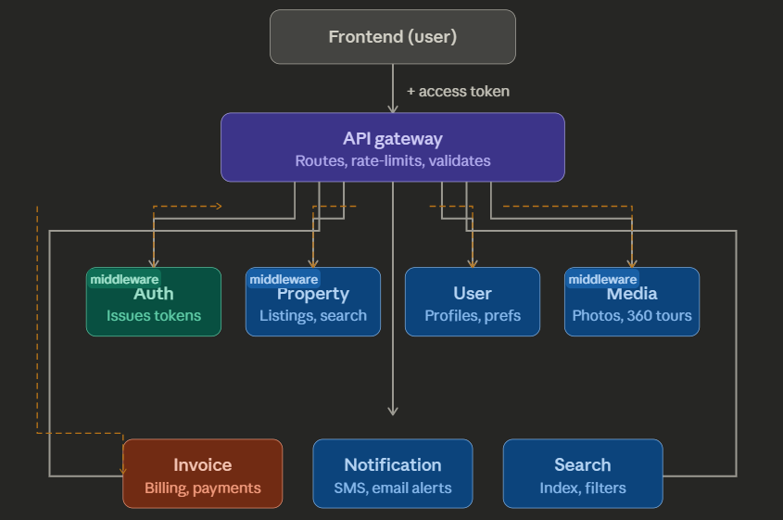
Figure 1: Microservices and API Gateway structure

4. JWT (Jason Web Tokens):-

JWT and APIs are closely linked because JWT is the standard way to authenticate and authorize API requests in modern web and mobile applications.

An API (especially a REST API) exposes endpoints (like GET /api/users, POST /api/orders) that clients call over HTTP. To protect these endpoints, the API uses JWT (JSON Web Token) as the access token. When a user logs in, the backend issues a JWT; the client then sends this token in the Authorization: Bearer <token> header with every API request. The API (or API gateway) verifies the JWT’s signature and claims (user ID, roles, expiry) and either allows or blocks the request, without storing server-side sessions.

Because JWT is stateless and compact, it makes APIs easier to scale, especially in microservices architectures where each service can independently validate the same token. In short:
APIs expose the functionality; JWT provides the secure, stateless, token-based identity and access control for those APIs.

5. Version Control and GitHub

5.1 What is Version Control?
Version control is a system that records changes to files and codebases over time, allowing developers to track history, review changes, and roll back to any previous state. It is the foundation of collaborative software development.

5.2 Git
Git is a distributed version control system. Unlike centralised systems, every developer has a full copy of the repository including its entire history, not just a snapshot. This means the team can work independently on their local machines and synchronise changes when ready.

- Repository: The project's container, storing all source code, metadata, and change history.
- Local repository: The copy of the project saved on a developer's own machine.
- Remote repository: The project hosted on a cloud platform such as GitHub, accessible to the whole team.
- Commit: A saved snapshot of the project at a specific point in time, with a message describing what changed and why.
- Branching: A workflow that allows developers to work on new features or bug fixes in an isolated copy of the codebase without affecting the main working version.

5.3 Monorepo Structure
ClearDeals maintains a personal repository on GitHub alongside an organisation repository that follows a monorepo structure. All projects — frontend, backend services, mobile app, admin panel, and Odoo custom addons — are stored within this single organisation repository rather than in separate repositories.

A monorepo (monolithic repository) is a version control strategy where code for multiple projects, libraries, and microservices lives in one place. The advantages in this context are:
- Unified navigation: developers do not need to switch between multiple repositories to understand the full system.
- Consistent dependency management across all services.
- Easier cross-service refactoring and atomic commits that touch multiple services at once.
- Simpler onboarding as the entire codebase is in one place.

6. Design Principles
The codebase follows OOP (Object-Oriented Programming) and SOLID principles throughout both the Node.js microservices and the Odoo Python addons. These principles ensure that code is modular, testable, and maintainable as the system grows:

- Single Responsibility: Each module, service, and model class has one clearly defined purpose.
- Open / Closed: Classes and modules are open for extension but closed for modification.
- Liskov Substitution: Inherited models behave consistently with their parent so that code depending on the base model continues to work with the extended version.
- Interface Segregation: Services expose only the API surface they need to, keeping interfaces small and focused.
- Dependency Inversion: High-level modules depend on abstractions (Odoo's ORM, REST interfaces) rather than on concrete implementations.

7. Odoo CRM

7.1 What is Odoo?
Odoo is an open-source business application platform written in Python. It provides a suite of integrated modules covering CRM, sales, accounting, inventory, HR, and more. Because it is open source, organisations can inspect the source code, extend existing modules, and build entirely custom ones. ClearDeals uses Odoo as its internal CRM and operational backbone, with several custom addons built on top of the core platform.

7.2 Custom Addons
Custom addons extend Odoo's standard behaviour. The ClearDeals addons are stored within the monorepo and cover the following domains:

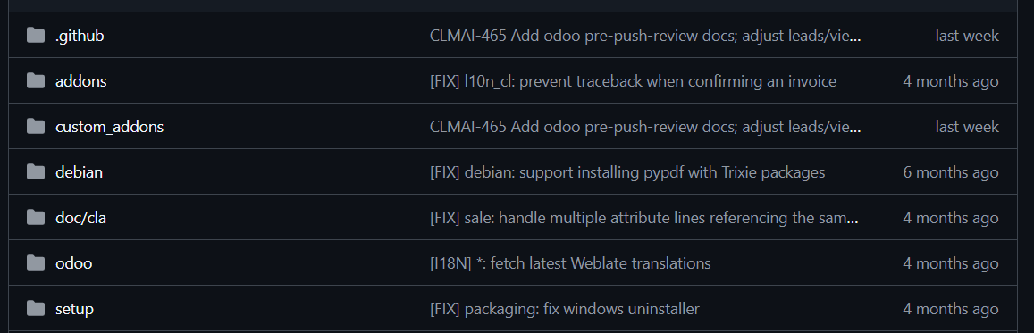
Figure 2: Custom addon folders in the repository

Each addon follows the standard Odoo Python-based structure. The key files and folders within any addon are explained in the table below.

Path / File | Purpose
addon_name/ | Root folder of the custom addon
__manifest__.py | Module metadata: name, version, dependencies, data files
__init__.py | Python package initialiser — imports models, controllers
models/ | Business logic — Python classes inheriting Odoo ORM models
views/ | XML view definitions — forms, lists, kanban, menus
security/ | Access control lists (ir.model.access.csv), record rules
data/ | Default/demo data loaded on module install
controllers/ | HTTP endpoints, webhooks, API config (app.py, web hooks, config)
static/ | Frontend assets — JS, CSS, images

The __manifest__.py File
Every Odoo addon must have a __manifest__.py file at its root. This file is a Python dictionary that declares all metadata Odoo needs to install and manage the module. The key fields are:

- name, summary, description: Human-readable identity of the module.
- author, category: Attribution and classification within the Odoo app store.
- version: The module version number (see Section 7 for the versioning scheme).
- depends: List of other Odoo modules this addon requires to be installed first.
- data: List of XML and CSV files Odoo loads on install — views, menus, security rules, and default data.
- security: Path to the ir.model.access.csv file that defines which user groups can read, write, create, or delete records.
- views: XML files defining how records are displayed — form views, list views, kanban boards, and menu items.
- controllers: Python files defining HTTP routes, webhook handlers, and API configuration endpoints.

The __init__.py File
The __init__.py file is the Python package initialiser for the addon. It imports the subpackages and modules (primarily the models folder) so that Odoo's module loader discovers and registers all model classes when the addon is installed or upgraded. Without the correct imports in __init__.py, model classes are invisible to the framework.

7.5 Models
Models are the core of any Odoo addon. Each model is a Python class that inherits from Odoo's ORM (Object Relation Mappin) base class (models.Model) and defines the fields and business logic for a specific entity. Odoo automatically maps these classes to PostgreSQL database tables.

The property.base model is the central data model. It is the single source for all property data and is referenced by other addons.

The res.users model is used to associate Odoo user accounts with properties and relationship managers. The property.py model file is used to extend or modify existing user-related behaviour within the property context.

7. Module Versioning
Odoo custom addon versions follow a five-part numbering scheme declared in the version field of __manifest__.py. Each segment has a specific meaning that communicates both the Odoo compatibility and the maturity of the addon.

Example version number:
19.0.1.4.0
19 | . | 0 | . | 1 | . | 4 | . | 0
Odoo series |  | Always 0 |  | Major changes |  | Minor increments |  | Patches

The five segments are:

- 19 — Odoo series. This number must match the major version of the Odoo instance the addon is installed on. Using version 19 here means the addon is designed for Odoo 19.
- 0 — This position is always 0 by convention in Odoo community addons.
- 1 — Major changes. Incremented when the addon introduces breaking changes, major new features, or structural database changes that require a migration script.
- 4 — Minor increments. Incremented when new non-breaking functionality is added, such as new fields, new views, or new computed methods.
- 0 — Patches. Incremented for bug fixes, small corrections, and cosmetic changes that do not affect the addon's data structure or public interface.

When the Odoo module is upgraded in a production instance, Odoo compares the installed version against the declared version in __manifest__.py. If the major segment (position 3) has changed, Odoo requires a migration script to update the database schema before the upgrade completes.

